**Experiment 1**

1.Create a simple cloud software application for Flight Reservation System using any Cloud Service Provider to demonstrate SaaS

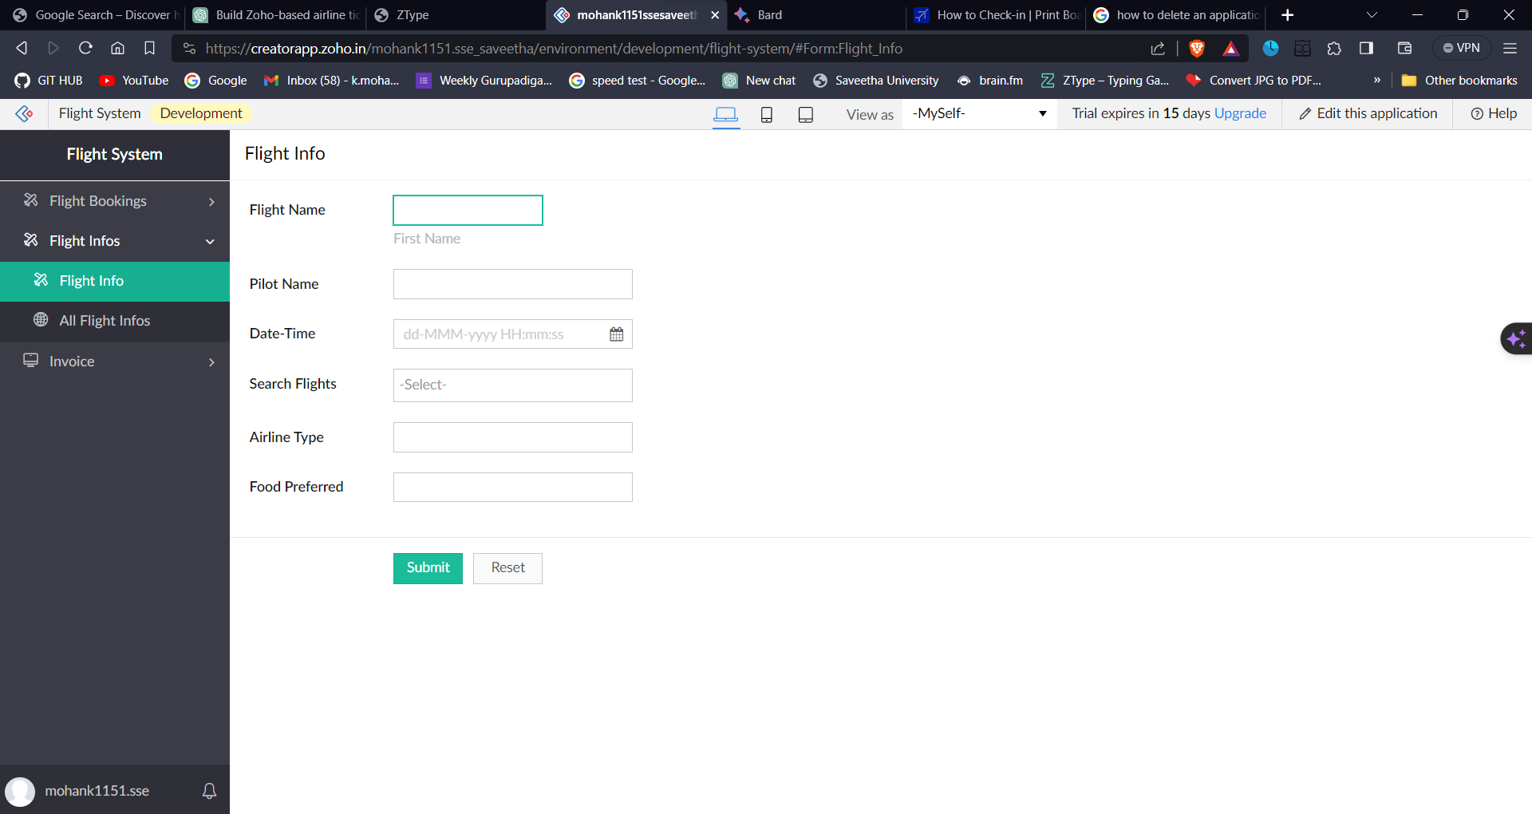

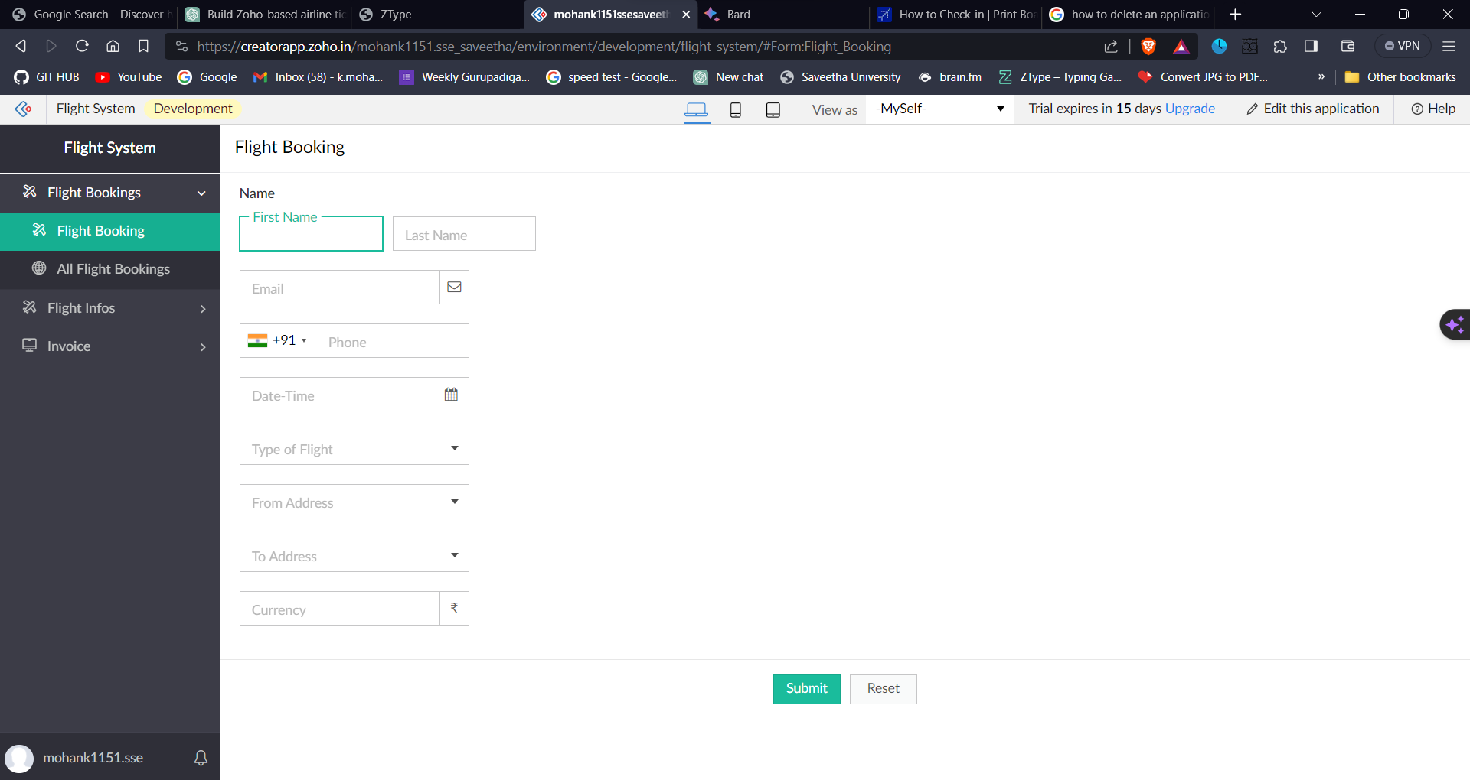**aS**

